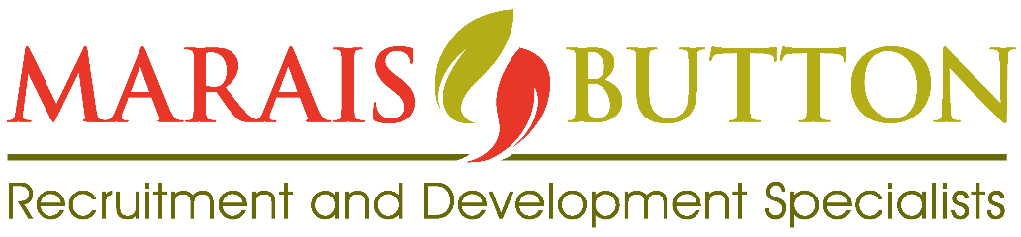

Thank you for sending us your CV. Regardless of if you are applying for a specific post or not, we do need you to please complete this form. Should you not be shortlisted for a specific post you applied for, you will automatically go onto our database for possible jobs that match your experience and skills. Note that we will be in contact with you as soon as a position becomes available that matches your skills, experience, and salary expectation. Without this information we cannot input you on our database.

POSITION INTERESTED IN / APPLYING FOR
PERSONAL INFORMATION
Date
Surname
First Name/s
Employment Equity Status
Contact Phone numbers | H: | W:
 | Mobile:
Another Contact Person if we cannot reach you | Name:
 | Contact numbers:
Skype address
Where did you hear about us?
ID Number and date of birth
Private E-mail address
(Check your SPAM folder regularly)
Home Language
Other languages (fluency)
Nationality
If not RSA nationality, state work permit & validity period/RSA permanent resident permit validity | (Include copy of Valid Permit)
Qualifications: Only list highest completed qualifications
Do you have a driver’s license?
Own Vehicle  (Please tick) | Yes | No
Current Employment (name of employer)
Current job title
Current /last Salary
(Total Cost to Company – before deductions)
ATTACH COPY OF LATEST SALARY ADVICE
Computer Literacy
(state IT programmes you are proficient in)
Notice Period {NP}: Please refer to your current employment contract to ensure your current NP is correct
Salary Requirement (including benefits) before deductions
Which province in RSA /country are you currently based?
If you are willing to relocate, please indicate to which provinces in RSA
Summary of technical key skills e.g. HIV/AIDS, project management etc.

Standard conditions of recruitment to be signed by every candidate who wishes to be on our database.

- MaraisButton & Associates shall be under no obligation to find employment for a candidate, but will endeavor to secure suitable employment.
- Under the POPIA, we are required to get your permission to share your personal information with potential clients for job vacancies.
- By signing this form, you are hereby entrusting us with your information.
- An offer of employment is not made until written details are received from the Client. MB&Assoc. does not accept any responsibility and shall not be liable for any loss suffered by the candidate by reason of the candidate’s decision to resign from his/her current employment or engagement before or after receipt of the client’s written offer.
- If, following an introduction from MB&Assoc., the candidate receives an offer of employment or any form of engagement to work for or with a client introduced by MB&Assoc, the candidate shall inform MB&Assoc. immediately and provide MB&Assoc. with full details of the offer. Should a client make direct contact with a candidate, it is the candidate’s responsibility to immediately inform MB&Assoc.
- If a candidate is shortlisted for an interview with a client and cannot attend the interview anymore, the candidate will phone the recruitment consultant immediately to inform her. Do NOT send a written notification including email or social media.
- The candidate undertakes to keep MB&Assoc. up to date with any changes in his/her CV and salary increase.
- Should a candidate no longer be on the job market then he/she must inform the recruitment consultant at MB&Assoc.

Signed on this day……………………………2022 at …………………………………………………………………..

Candidate name: ……………………………………………………………………………………………………………….

Candidate signature: …………………………………………………………………………………………………………

We are committed to our clients every step of the way and we understand the importance of cultural fit and making it a priority to our clients and candidates. At MaraisButton & Assoc., we believe that the safeguarding of our clients’ and candidates' personal information is of paramount importance. To this end, we have various measures in place to ensure that our data policies and procedures are reflective of our clients’ and candidates' best interests and aligned with industry best practices. There are, however, various regulatory requirements that we also need to adhere to, one of which is the Protection of Personal Information Act (also referred to as POPIA), which has come into effect from 1 July 2021. There is no action required from you once POPIA comes into effect. In conclusion, we would like to assure you that we will continue treating your personal information with the utmost care and integrity.
If you have any questions, please feel free to contact us directly.

